Alkyl Halide Reaction from a Primary Alcohol
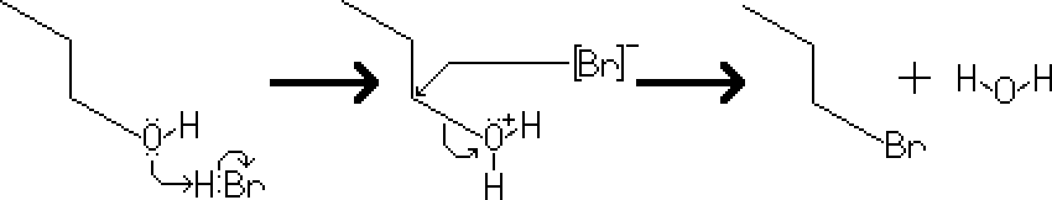
Reactants – Primary or Secondary Alcohol, HBr
Products – Primary or Secondary Alkyl Halide, Water
Electron Movement
- SN2 Reaction – The hydroxy is protonated, created a good leaving group. [H₂O] This allows the bromide, acting as a nucleophile, to attack the carbon of the substrate, while the leaving group disassociates from the compound, creating an alkyl halide.

Notes
- For tertiary and some secondary alcohols, an alkyl halide reaction would still occur, however the electron movement would follow the SN1 mechanism.

